A

PROJECT REPORT

ON

ENHANCED E-HR SYSTEM

submitted in partial fulfillment of the requirement of the degree of

**BACHELOR OF ENGINEERING**

**IN**

**COMPUTER ENGINEERING**

BY

Armaan Nakhuda (20220164402277961)

Sushant Navle (2022016402277791)

Samay Pandey (202216402279163)

Peeyush Karnik (2021016402104651)

Guide:

Vedika Patil



**Department of Computer Engineering**

K.C. College of Engineering and Management Studies And

Research, Thane (E)

University of Mumbai

2023-24

CERTIFICATE

This is certify that the mini project entitled **“ENHANCED E-HR SYSTEM’’** is Bonafede work of **Armaan Nakhuda (B-02); Sushant Navle (B-05); Samay Pandey (B-09); Peeyush Karnik (B-57)** submitted to the University of Mumbai in partial fulfillment of the requirement for the award of the degree of **“Bachelor of Engineering”** in **“Computer Engineering”.**

Guide

Prof. Vedika Patil

Head of Department Principal

Prof. Mahesh Maurya Dr. Vilas Nitnavare

**Project Report Approval for S.E.**

This mini project entitled ***ENHANCED E-HR SYSTEM*** by ***Armaan Nakhuda (B-02); Sushant Navle (B-05); Samay Pandey (B-09); Peeyush Karnik (B-57)*** is approved for the degree of Bachelor of engineering in Computer Engineering.

Examiners

1..............................................................................

(Internal Examiner Name & sign)

2.....................................................................

(External Examiner name & sign)

Date: -

Place: -

DECLARATION

We declare that this written submission represents our ideas in our own words and where others' ideas or words have been included, we have adequately cited and referenced the original sources. We also declare that we have adhered to all principles of academic honesty and integrity and have not misrepresented or fabricated or falsified any idea/data/fact/source in our submission. We understand that any violation of the above will be cause for disciplinary action by the Institute and can also evoke penal action from the sources which have thus not been properly cited or from whom proper permission has not been taken when needed.

(signature)

[Armaan Nakhuda (20220164402277961) 02]

[Sushant Navle (2022016402277791) 05]

[Samay Pandey (202216402279163) 09]

[Peeyush Karnik (2021016402104651) 57]

Date: -

**ACKNOWLEDGEMENT**

We would like to express special thanks of gratitude to our guide **Mrs. Vedika Patil** who gave us the golden opportunity to do this wonderful project on the topic of **Enhanced E-HR system**, which also helped us in doing a lot of research and we came to know about so many new things. We are very grateful to our Head of the Department **Prof. Mahesh Maurya** for extending her help directly and indirectly through various channels in our project work**.** We would also like to thank Principal **Dr. Vilas Nitnaware** for providing us the opportunity to implement our project. We are really thankful to them. Finally, we would also like to thank our parents and friends who helped us a lot in finalizing this project within the limited time frame.

Thanking You.

Contents

Abstract

List of abbreviations

List of figures

1. Introduction

1.1 Introduction

1.2 Motivation

1.3 Problem Statement & Objectives

2. mini project contribution

3. Proposed System

3.1 Introduction

3.2 Architecture or Framework

3.3 Details of hardware and software

3.4 Experiment and Results

3.5 Conclusion and future work

4. References

1

List Of Figure

|  |  |  |
| --- | --- | --- |
| Figure  no. | Figure Name | Page no. |
| 1. |  |  |
| 2. |  |  |
| 3. |  |  |
| 4. |  |  |
| 5. |  |  |
| 6. |  |  |
| 7. |  |  |

2

Abstract

The Enhanced E-HR system is a comprehensive software application designed to streamline and enhance human resource management processes within an organization. The system employs a user-friendly graphical interface developed using Python, providing an easy experience for users. Key features include secure user authentication, role-based access control, and a responsive design that adapts to varying screen sizes.

The application integrates Firebase, a cloud-based database service, for secure storage and retrieval of user credentials. This ensures data integrity and allows administrators to manage user access and permissions efficiently. The system caters to different user roles, including administrators, HR personnel, bosses, and employees, each with tailored functionalities.

The login interface serves as the gateway to the system, allowing users to access role-specific modules. The modular design facilitates easy future enhancements. Admins can manage system credentials through Firebase, ensuring a centralized and secure user management system

The HR, employee, and boss modules offer distinct functionalities tailored to the respective roles. These include access to employee records, performance evaluations, and administrative tasks. The system incorporates dynamic resizing of background images, providing a visually appealing and responsive user interface.

The project aims to improve HR management efficiency, reduce manual workloads, and enhance overall organizational productivity. By leveraging modern technologies, the Enhanced E-HR system contributes to the digital transformation of HR processes, promoting a more streamlined and effective approach to human resource management.­­

3

List Of Abbreviation

List of Abbreviations for Enhanced E-HR system:

1. HRMS: - Human Resource Management System
2. DBMS: - Database Management System
3. DB: - Database

This list provides a quick reference to the abbreviations used in the Enhanced E-HR system

4

INTRODUCTION

1.1 Introduction

In the dynamic landscape of modern organizations, the effective management of human resources is paramount to achieving strategic goals and maintaining a competitive edge. The Enhanced E-HR system emerges as a comprehensive solution, seamlessly integrating technology and human resource management practices to streamline processes, enhance efficiency, and foster a more strategic approach to workforce management.

The Enhanced E-HR system serves as the central hub for all HR-related activities within an organization, providing a robust platform for managing employee information, recruitment, performance appraisal, training, and more. This system not only automates routine HR tasks but also empowers HR professionals with valuable insights through analytics, aiding in informed decision-making.

In this digital age, ENHANCED E-HR SYSTEM With the advent of technology it consolidates and centralizes employee data, providing a secure and accessible repository for personal details, qualifications, and performance records.

Facilitating employee development, the Enhanced E-HR system aids in planning, implementing, and tracking training programs to enhance skills and knowledge.

As organizations continue to recognize the strategic importance of their human capital, it emerges as a critical tool in fostering a positive employee experience, ensuring compliance with regulations, and driving organizational success. This introduction sets the stage for exploring the various dimensions and functionalities of the Enhanced E-HR system, ultimately contributing to the evolution of modern HR practices within the organization.

5

1.2 Motivation for Creating A ENHANCED E-HR SYSTEM

The motivation behind the development of the Enhanced E-HR system stems from the growing need for organizations to optimize and modernize their human resource management processes. As businesses evolve in today's dynamic environment, efficient HR management becomes crucial for organizational success. Traditional manual methods are often time-consuming, prone to errors, and lack scalability. The Enhanced E-HR system aims to address these challenges by providing a comprehensive, user-friendly, and technologically advanced solution.

**1. Objectives**

* **Streamlining HR Processes:** The primary objective is to streamline various HR processes, including employee record management, performance evaluation, and administrative tasks. Automation reduces manual efforts, minimizes errors, and accelerates processes.
* **Enhancing User Experience:** The system is designed with a focus on user experience, employing a graphical interface for ease of use. Dynamic resizing of background images ensures a visually appealing and responsive platform, enhancing overall user satisfaction.
* **Role-Based Access Control:** Implementing role-based access control ensures that each user, be it an administrator, HR personnel, boss, or employee, has access only to the functionalities relevant to their role. This enhances security and data privacy.

**2. Technology Stack:**

The use of technologies such as Tkinter for the graphical interface, Pillow for image processing, and Firebase for database management contributes to the system's robustness and scalability. The integration of Firebase ensures secure storage and retrieval of user credentials, aligning with modern cloud-based solutions.

6

1.3 Problem Statements and Objectives

Problem Statements: -

In contemporary organizational environments, traditional human resource management practices often face significant challenges, hindering operational efficiency and limiting the potential for strategic HR contributions. Manual processes, lack of centralized data management, and inadequate automation lead to inefficiencies, errors, and delays in critical HR functions. The absence of a streamlined system compromises data security, inhibits quick decision-making, and impedes the overall effectiveness of HR processes.

1. **Manual and Time-Consuming HR Processes:** Traditional HR management practices heavily rely on manual processes, leading to inefficiencies and delays. Tasks such as employee record management, leave approvals, and performance evaluations are time-consuming and error-prone, hampering the overall productivity of the HR department.
2. **Lack of Centralized Data Management:** Existing HR systems often suffer from fragmented data storage, making it challenging to maintain a centralized and cohesive repository of employee information. This fragmentation results in data redundancies, inconsistencies, and difficulties in extracting meaningful insights for strategic decision-making.
3. **Security Concerns and Unauthorized Access:** Many HR systems lack robust security measures, exposing sensitive employee information to potential breaches. The absence of proper authentication and authorization mechanisms allows unauthorized access to confidential HR data, posing a significant security risk for the organization.
4. **Inadequate Role-Based Access Control:** The absence of role-based access control exacerbates security concerns, as users often have unrestricted access to all system functionalities. This not only compromises data security but also violates the principle of least privilege, hindering the establishment of a secure and compliant HR environment.

7

Objective: -

**1. Streamlining HR Processes:**

* Develop a comprehensive Enhanced E-HR system that automates and streamlines routine HR processes, such as employee record management, performance evaluations, and administrative tasks.

**2. Enhancing Data Security:**

* Implement robust security measures, including secure user authentication and role-based access control, to ensure the confidentiality and integrity of sensitive employee information.

**3. Improving User Experience:**

* Design a user-friendly graphical interface with dynamic resizing capabilities to enhance the overall user experience, ensuring that the system is accessible and engaging for all users, regardless of their technical proficiency.

**4. Implementing Modern Technologies:**

* Utilize modern technologies such as Tkinter for the graphical interface, Pillow for image processing, and Firebase for database management to create a technologically advanced and scalable Enhanced E-HR system.

**5. Facilitating Digital Transformation:**

* Contribute to the organization's digital transformation by providing a platform that aligns with modern HR practices, encourages automation, and supports strategic decision-making.

**6. Role-Specific Functionalities:**

* Develop role-specific modules catering to the unique needs of administrators, HR personnel, bosses, and employees, ensuring that each user has access only to functionalities relevant to their role.

**7. Scalability and Future Enhancements:**

* Design the system with a modular architecture to allow for easy scalability and future enhancements, ensuring adaptability to evolving organizational requirements.

8

2.Mini Project Contribution

The workflow was divided and done by all the members of the project group, the work done by each member is as follows:

1. Armaan Nakhuda: Exit and Credits button on login screen

Resizing, centering, and focusing of all windows

Manager Window

50% of Employee window

Documentation and ppt (error checking)

1. Sushant Navle: Basic Login page and admin login screen (no buttons)

Documentation

PPT

1. Samay Pandey: Implementation and connection of DB

Dynamic name on every window

Admin window

HR window

50% of Employee window

Documentation and ppt (flowcharts error checking)

1. Peeyush Karnik: Documentation

PPT

9

3.Proposed System

3.1 Introduction

Traditional HR practices face challenges in efficiency and security. Our proposed Enhanced E-HR system introduces automation, centralized data management, and robust security measures. With a user-friendly interface and modern technologies, the system aims to streamline operations, enhance data integrity, and align with organizational digital transformation goals, empowering HR professionals for organizational success.Top of Form

3.2 Architecture

The Enhanced E-HR system aims to revolutionize HR processes for enhanced efficiency and streamlined operations. This report provides a comprehensive overview of the system architecture.

1. User Interface: -

1. Intuitive design for employee self-service and admin dashboards.
2. Responsive and user-friendly interface.

2. Database Management: -

a. Centralized database for secure storage of employee data.

b. Database management system for efficient data retrieval.

3. Application Logic: -

a. Employee Onboarding: Digital forms and document submission.

b. Attendance Tracking & Performance Records

c. Performance Management: Goal setting, feedback mechanisms.

d. Employee Self-Service: Leave requests and personal information.

4. Technologies Used: -

a. Frontend: Python

b. Database: Firebase

10

Flowchart: -

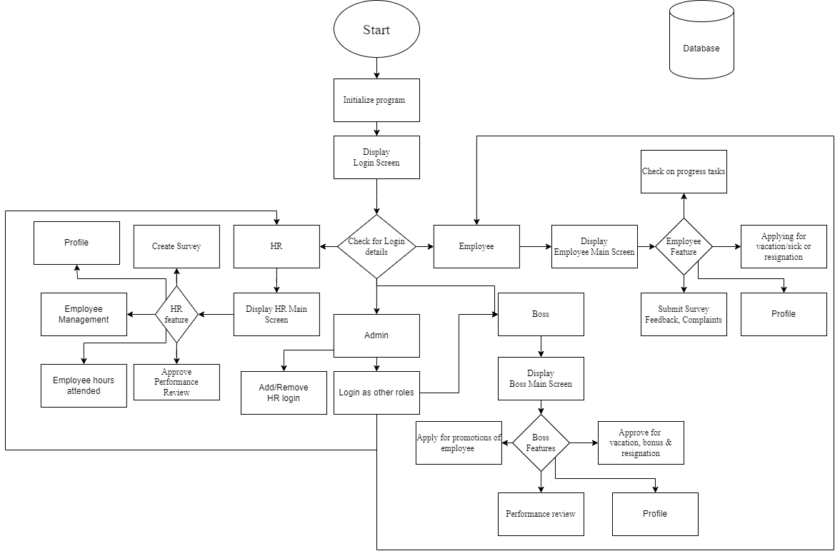

Figure 1

Figure 1 is a flowchart of the basic showcase of Enhanced E-HR system.

1. Initialization: Login screen helps to identify if the user is Admin, HR, Boss or Employee.
2. Database: The user is then given the features with respect to it’s login details.
3. Features: These are differentiated between Admin, HR, Boss and Employee respectively.
4. Admin: This user can remove or add login details of HR/Manager/Employee and sign in as per what permission level is desired.
5. HR: This user can Add or remove manager/employee, manage salary and approve feedbacks, etc.
6. Boss: This user can View performance, approve for vacation/sick leaves or resignations, bonus or promotions, etc.
7. Employee: This user can check progress, apply for leaves, submit survey or apply for vacations, etc.

11

3.3 Hardware and Software Requirements: -

Hardware: -

1. Minimum Requirements:
2. Processor: - Dual core processor @2.4Ghz
3. Ram: - 4GB Ram
4. Storage: - 2GB free space
5. Internet: - speed: 3mbps
6. Recommended Requirements:
7. Processor: - Quad core processor @2.8Ghz
8. Ram: - 8GB Ram
9. Storage: - 4GB free space
10. Internet: speed: 6mbps

Software: -

1. Minimum Requirements:
2. OS: Windows 10 22H2
3. Python: Version 3.11 with pil, firebase, firebase_admin and tkcalendar modules installed
4. Recommended Requirements:
5. OS: Windows 11 22H2
6. Python: Version 3.12 with pil, firebase, firebase_admin and tkcalendar modules installed

12

* 1. Experimental Result: -

Main login:

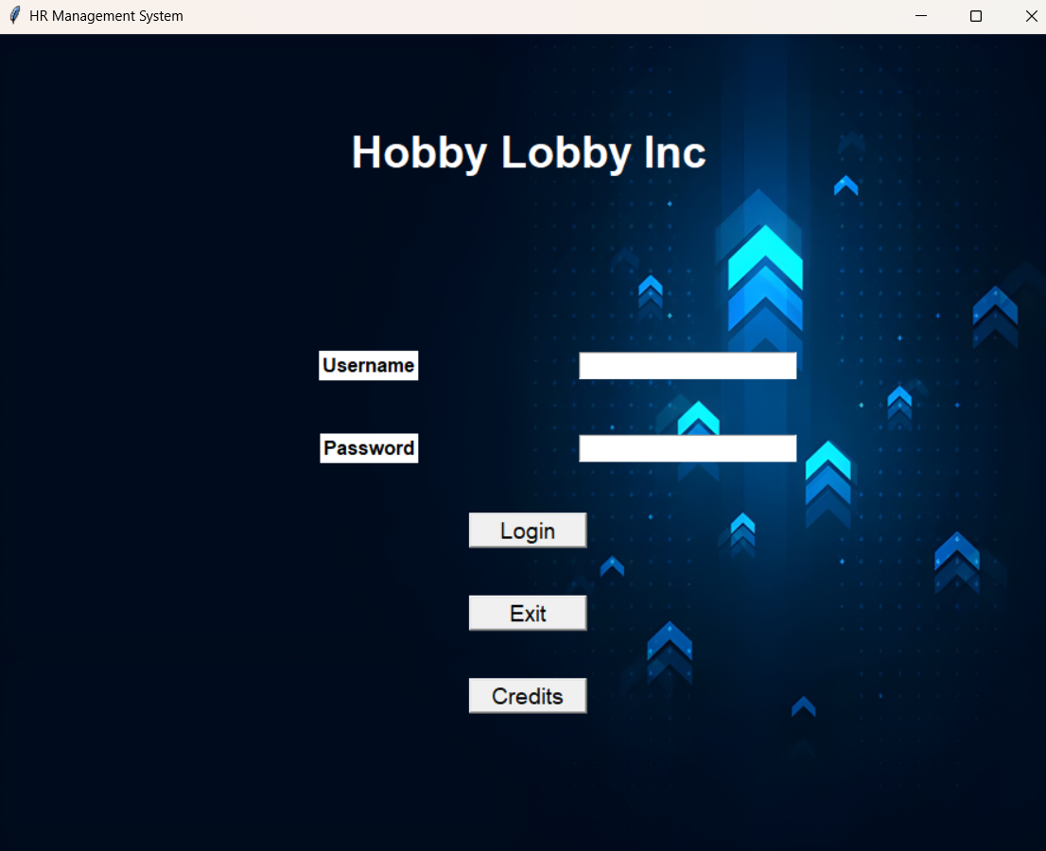

Figure 2

Figure 2: The first page presented to the user upon opening the application, this page gives the input boxes to enter the username and password along with the login button and the exit and credit buttons.

There are 4 types of windows which will open following the user’s login depending on what role has been assigned the user in the DB, the 4 types of logins are Admin, HR, Manager and Employee.

13

Credits Dialog box in main login screen:

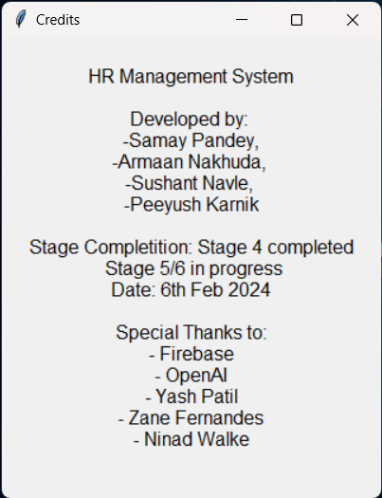

Figure 3

Figure 3- The Credits dialog which opens after clicking the credits button on the main login page.

14

Admin Screen:

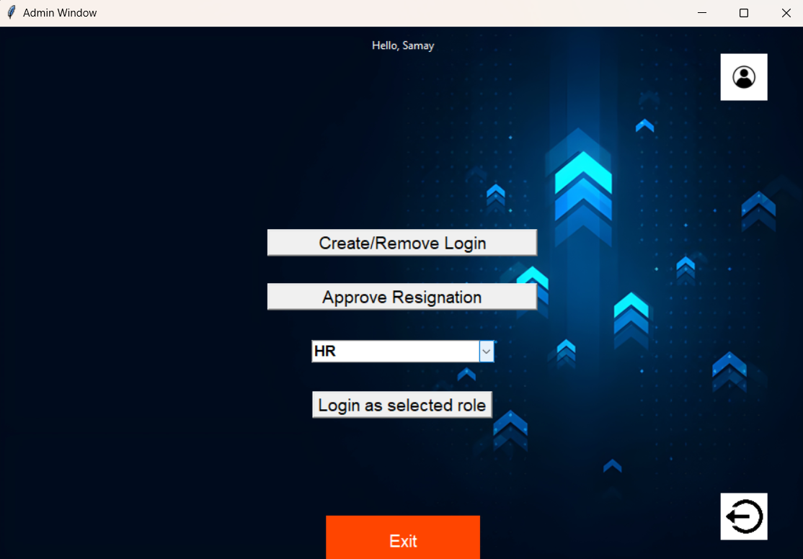

Figure 4

Create/Remove Login: This button will allow the admin to add or remove logins of HR, Manager or Employee. (Figure 5) Also the logout button if you press on login button then it will directly go to the main login page

Login as Selected Role: The Admin will have an option to simulate as different levels of logins if he/she needs to view or test something as a different permission level.

15

Create/Remove Login:

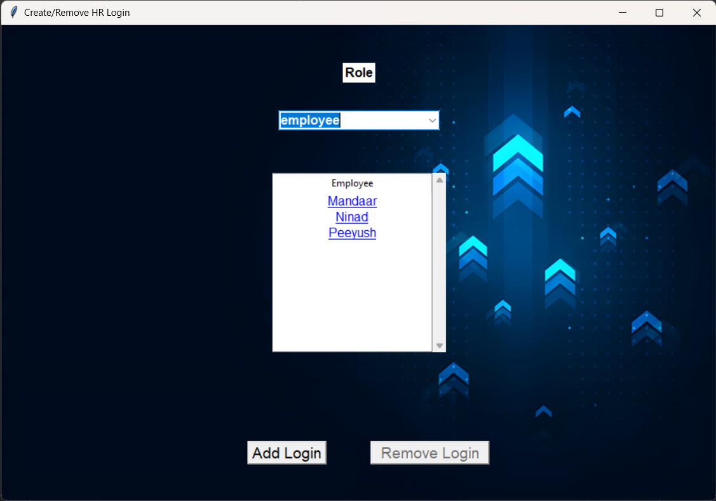

Figure 5

Figure 5- the first screen that is displayed to the user when the Create/Remove button is pressed, this screen gives the Admin the option to select the category of role so the logins of that role are shown, upon it being shown the Admin can select one role and delete it. (Figure 6 and 7).

Clicking the Add login button, opens a new window (Figure 8)

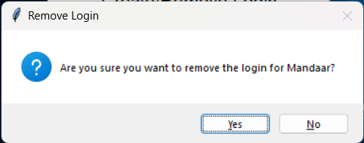 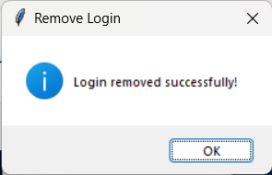

Figure 6 Figure 7

Figure 6 and 7: gives the confirmation and success popups for the removal of the login.

16

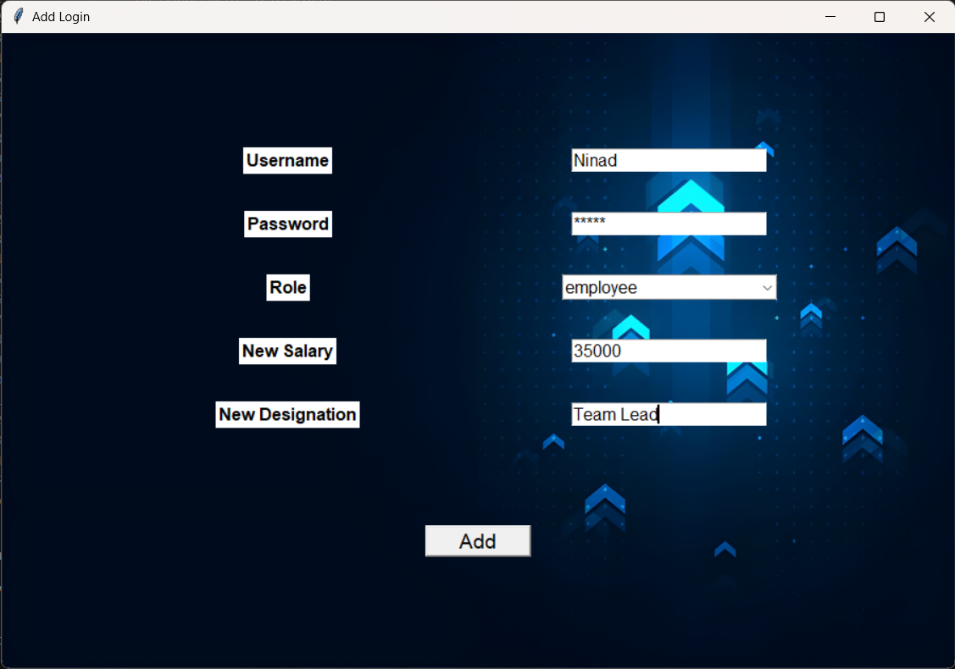

Figure 8

Figure 8- Shows the window to provide details for the new login to be added to the DB.

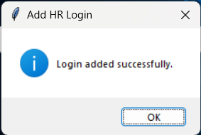

Figure 9

Figure 9: shows the confirmation that the login has been added to the database successfully.

17

Approve Resignation: -

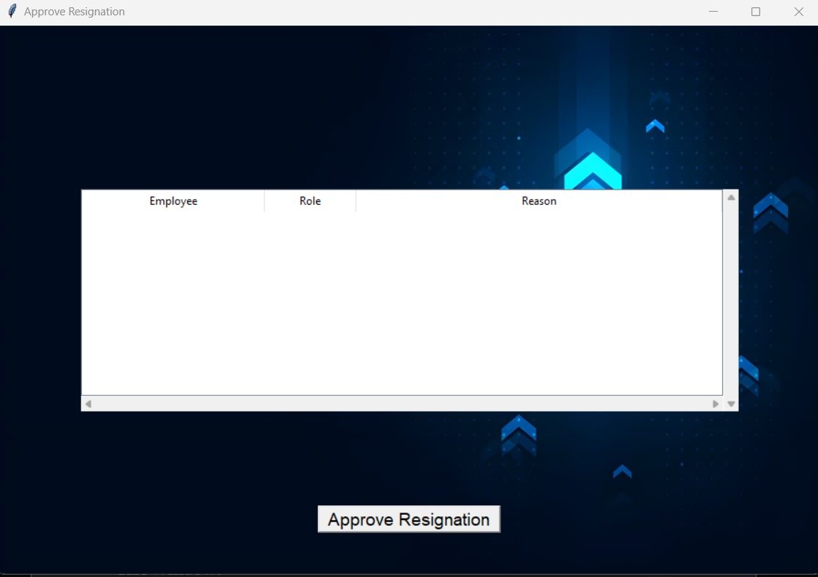

Figure 10

Here the admin role can approve for the resignation of a particular profile. It can also review the given reasons from the employees regarding there resignation reasons and their details such as there following roles and respective names.

18

HR Window:

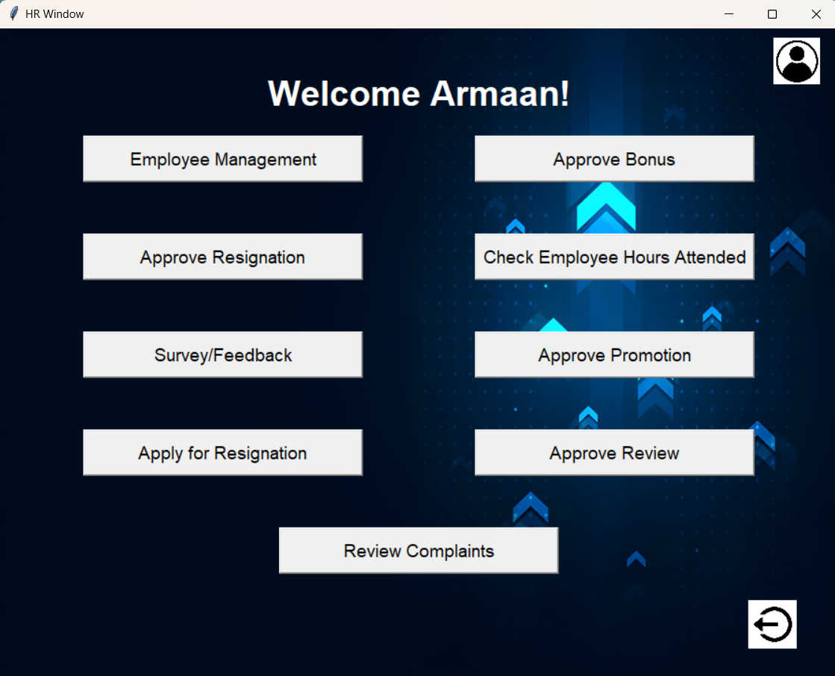

Figure 11

Figure 11: The first screen shown to the HR when the user logins in, it has buttons like employee management (figure 12) to manage Managers and Employees, Approve and assign bonus to employees (figure 19) and grant bonus (figure 23) respectively, approve resignations for Managers and employees (figure 26) and send out survey with specified questions to the employees to be filled (figure 27) and approve for promotion of employee (Figure 30).

19

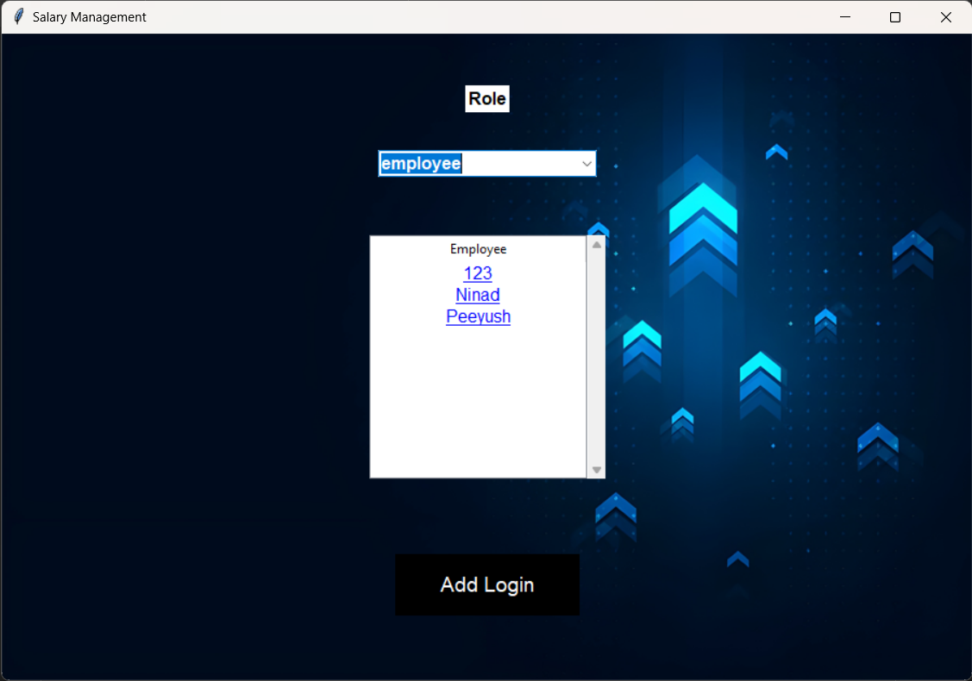

Figure 12

Figure 12: When the Employee Management button is clicked, this window will appear to the user which includes a toggle to select the role between manager and employee, upon selecting the role all the logins within that role will show up in the list below, the user can then click on any name to show the details of the employee as shown in figure 13.

The add login button will open a new window which allows to input the details for the new login as shown in figure 9.

20

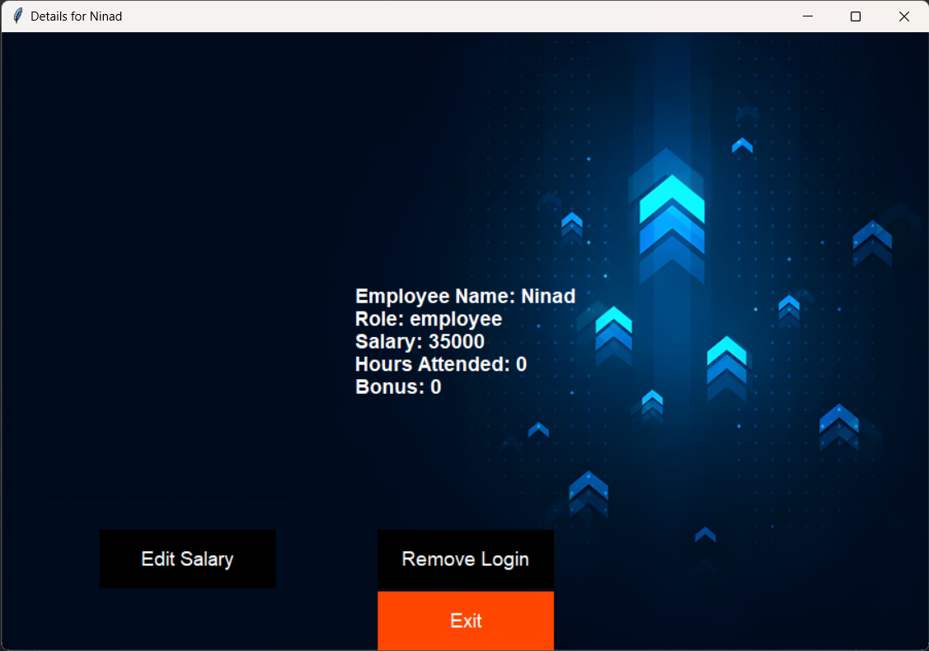

Figure 13

Figure 13: The details of the employee that was clicked is shown in a new window, along with the option to edit the salary (figure 14) and remove the specified login (figure 17) for the employee.

21

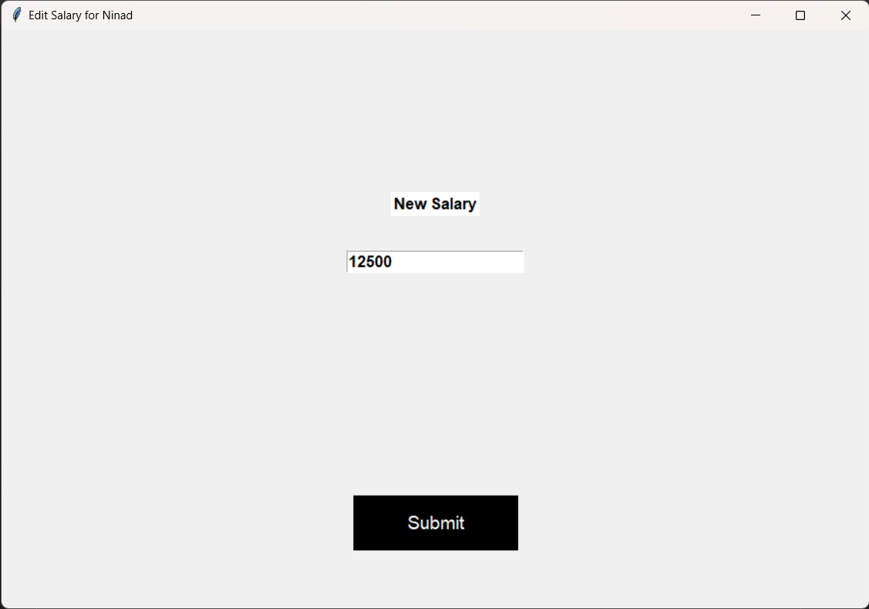

Figure 14

Figure 14: When the user clicks on edit salary button a new window will open asking for the input for the new salary of the Manager/Employee.

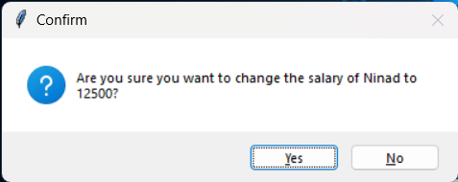

Figure 15

Figure 15: Shows the confirmation asking if the new salary is correct and this new salary should be uploaded the DB.

22

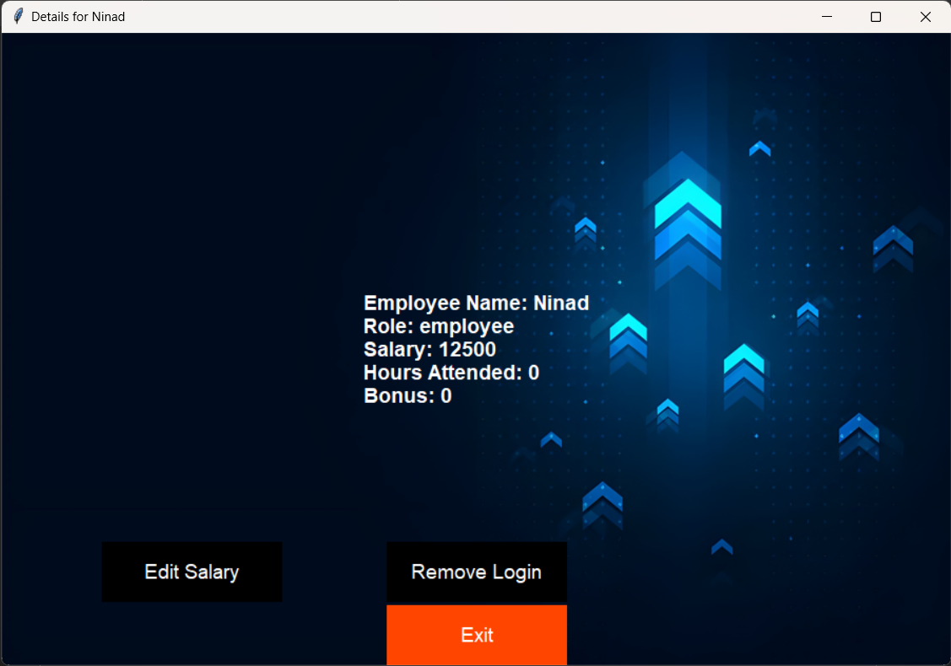

Figure 16

Figure 16: Shows the updated salary in the details window.

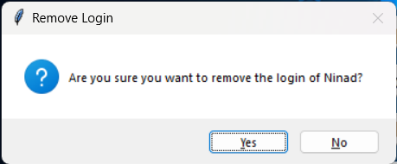 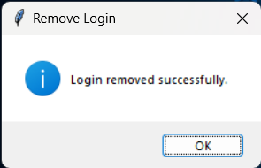

Figure 17 Figure 18

Figure 17 and 18: Shows the Dialog box asking for confirmation and the success dialogs if the HR clicks on yes to delete the login of the user.

23

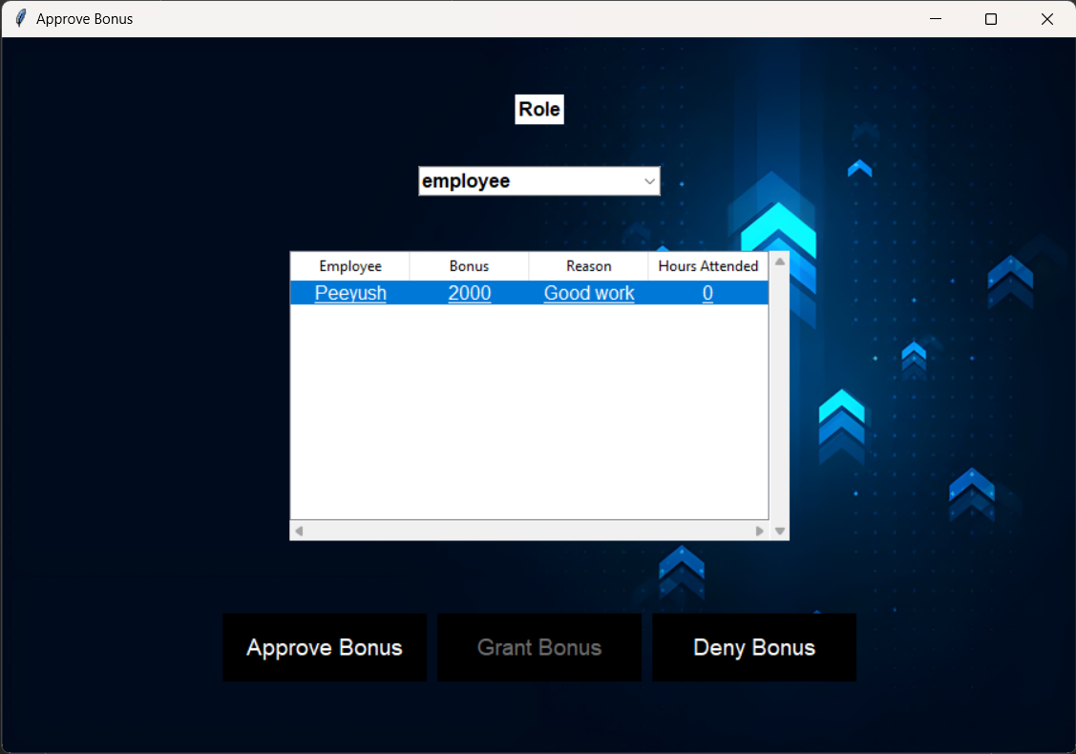

Figure 19

Figure 19: The Employee bonus is requested by the Manager and has to be approved by the HR, giving the HR two options to either approve or deny the request.

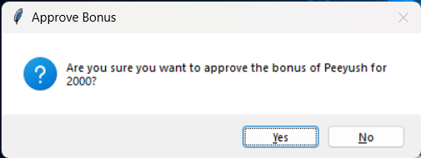 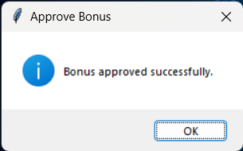

Figure 20 Figure 21

Figure 20: When the approve or deny button is clicked another confirmation is displayed for the respective action.

Figure 21: Shows the dialog box that the action has been completed and the update has been pushed into the DB.

24

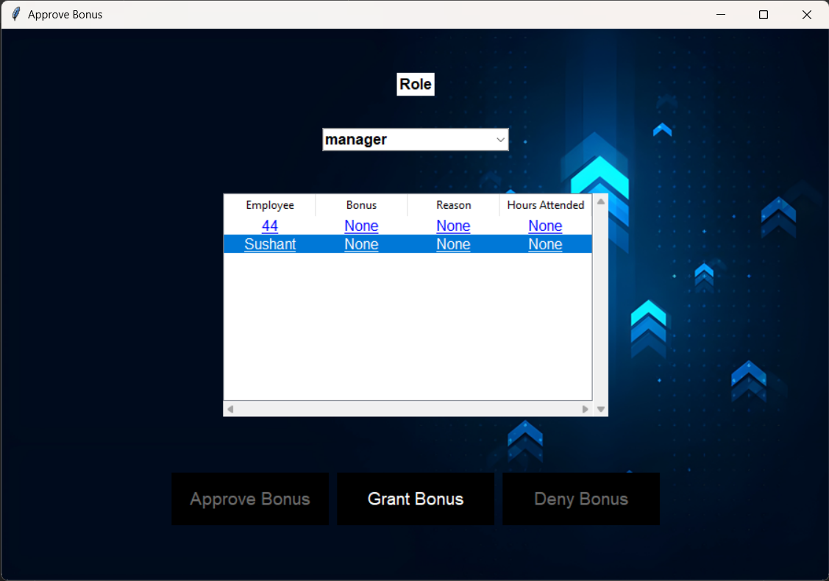

Figure 22

Figure 22: For Manager level the HR directly gives bonus on their discretion, therefore the grant bonus option is available which when clicked opens a new window (figure 23).

25

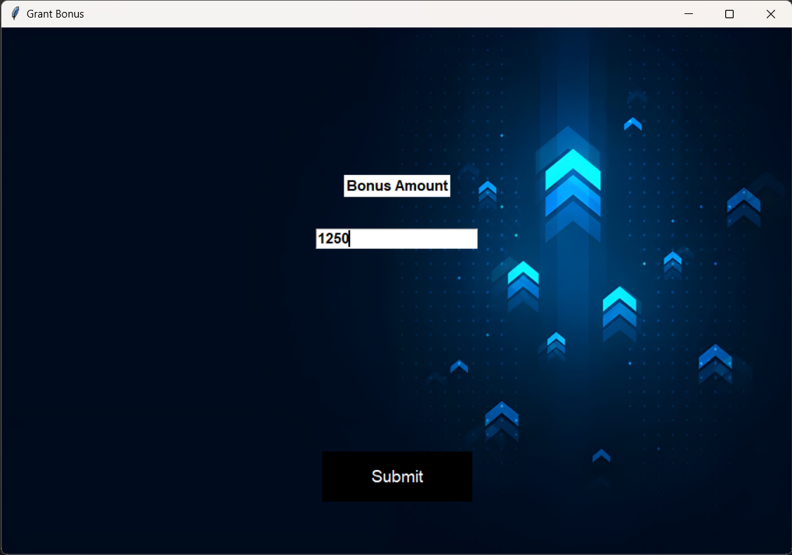

Figure 23

Figure 23: Gives the HR the input box to input the amount of bonus that should be provided the specified Manager, on clicking the submit button (figure 23) is shown.

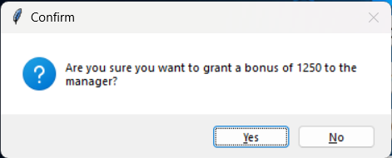 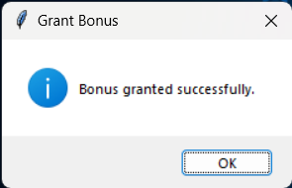

Figure 24 Figure 25

Figure 24 and 25: The confirmation dialog is shown to the user, upon clicking yes the details are updated into the DB and the success dialog is shown.

26

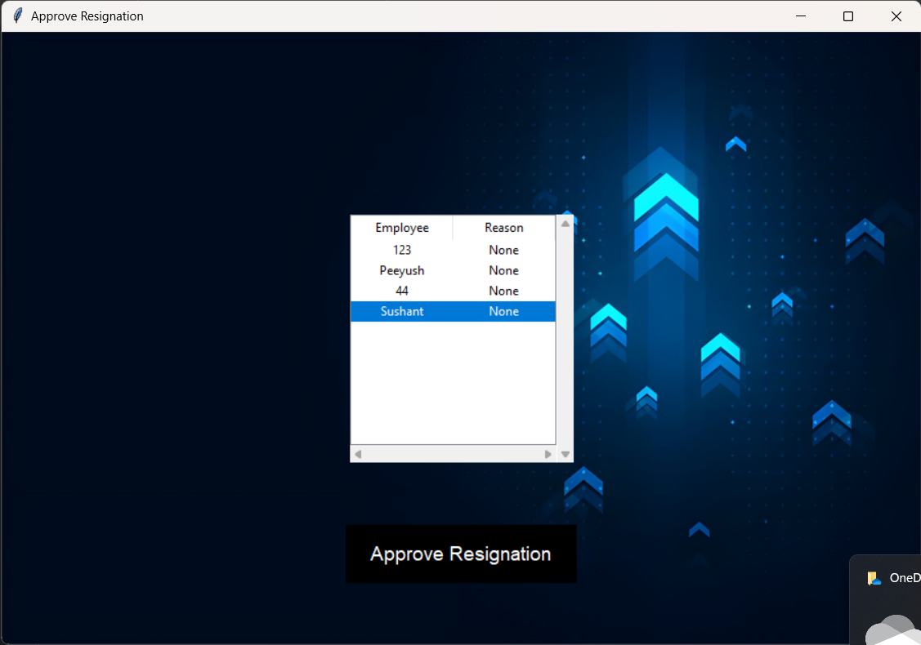

Figure 26

Figure 26: Upon clicking the Approve resignation button a new window shows up with the list of employees whose resignation approval is pending, upon clicking the respective employee the approve button highlights itself which can then be clicked to approve the resignation.

27

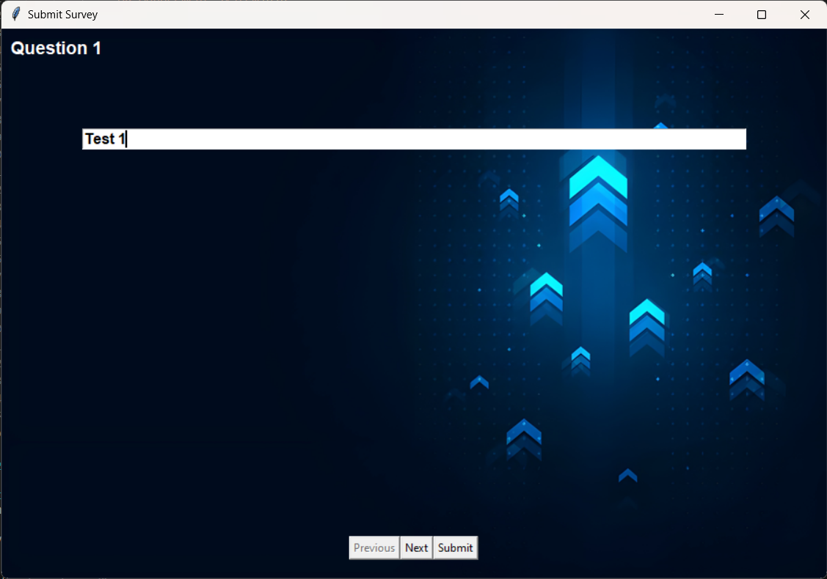

Figure 27

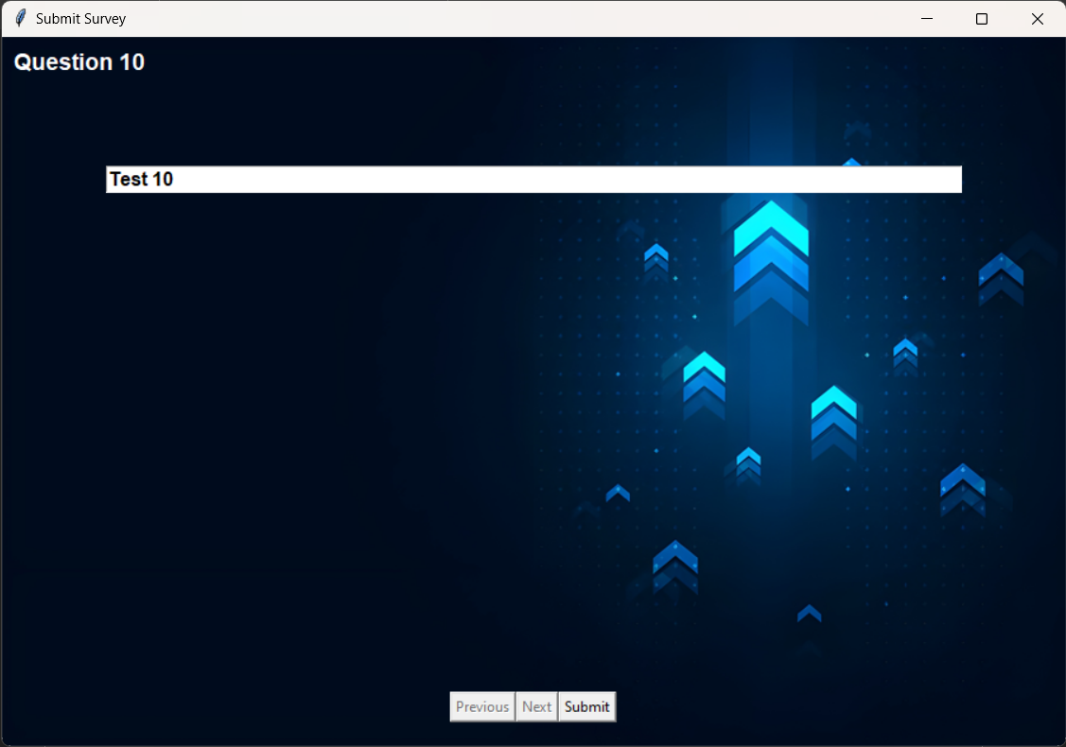

Figure 28

28

Figure 27 and 28: Show the first and last question of the survey along with the previous next and submit buttons to move between the questions and to assign the survey for the employees to fill it.

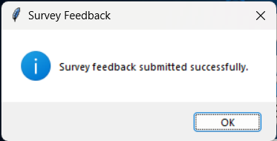

Figure 29

Figure 29: The dialog box that is presented to the user when the submit button is clicked and the new questions have been assigned in the DB.

29

Approve for promotion: -

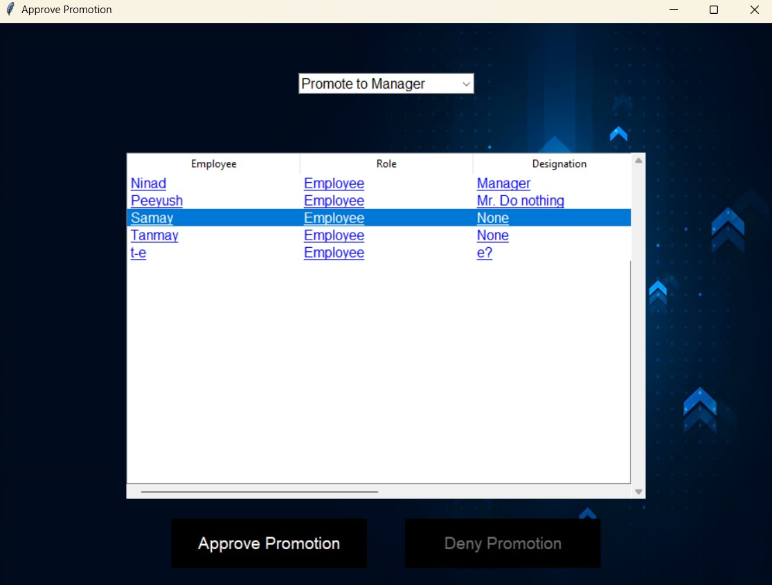

Figure 30

Figure 30: - Upon clicking the Approve promotion button a new window shows up with the list of employees whose promotion approval is pending, upon clicking the respective employee the approve button highlights itself which can then be clicked to approve the promotion.

30

Profile For HR: -

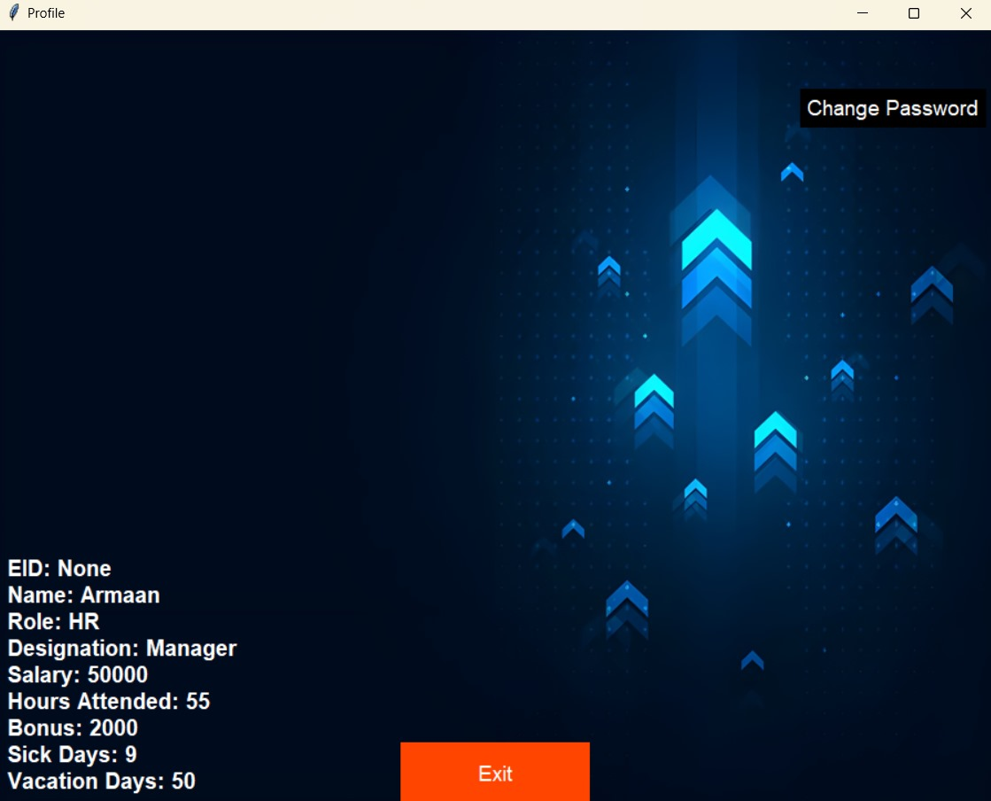

Figure 31

Figure 31: -This Profile screen represents the details for the HR which shows the Name, EID, Role, Designation, Salary, Hours Attendended, Bonus and Sick days leave/ Vacation days leave. The user is also able to change its password through this screen

31

Review Complaint: -

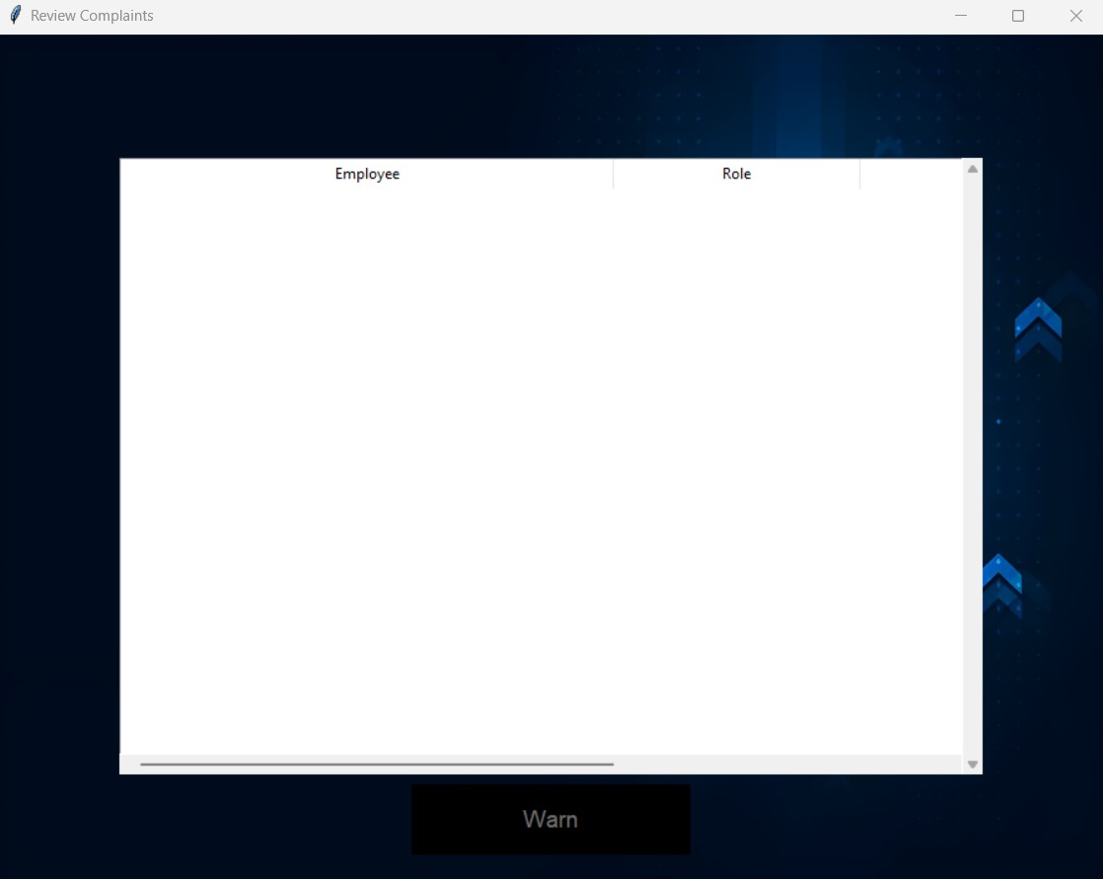

Figure 32

In the given figure (32) HR role can review the complaints regarding the employee which only be viewed by HR are observed. The details of the employee as well as the role of the employee is shown in the respective figure. With this the HR can directly give a warning statement to the employee regarding the matter personally.

32

Manager Window:

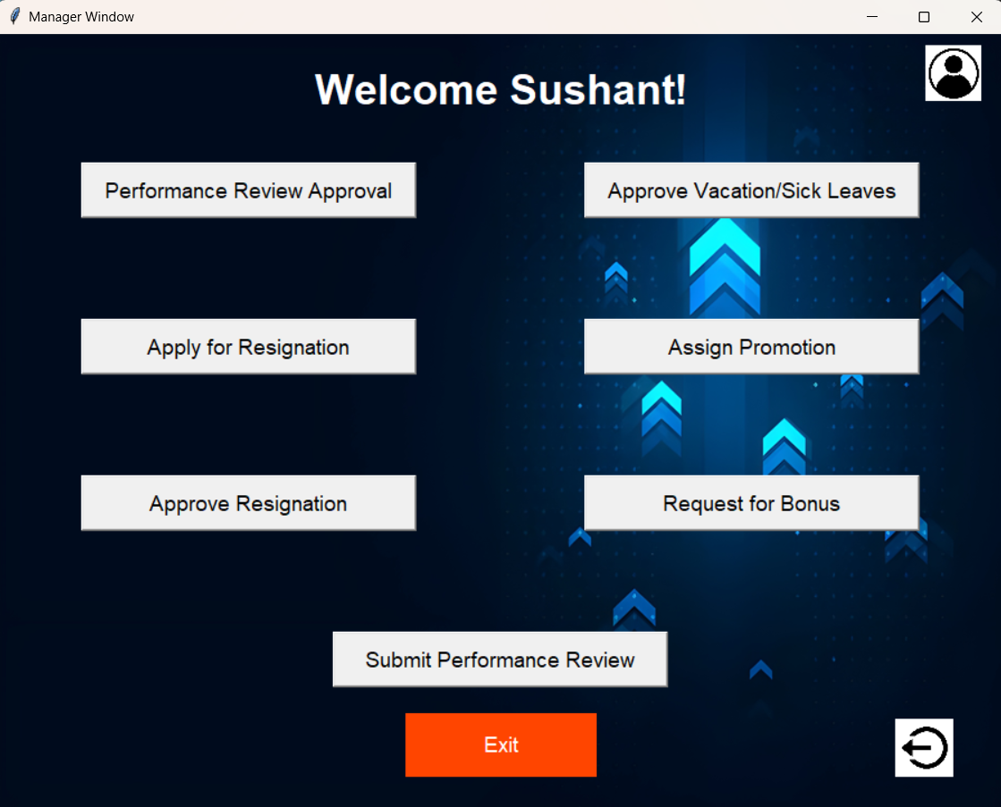

Figure 33

Figure 33: The window that is shown to the user who logs in at the manager level, the user has the options to approve performance reviews (figure 35), approve vacation/sick leaves (figure 36), check progress on tasks which are in progress by employees, assign promotions (figure 42), approve resignation (figure 45) and request for bonus for employees (figure 39).And Additionally a log button is provided for the user to log out of this profile

33

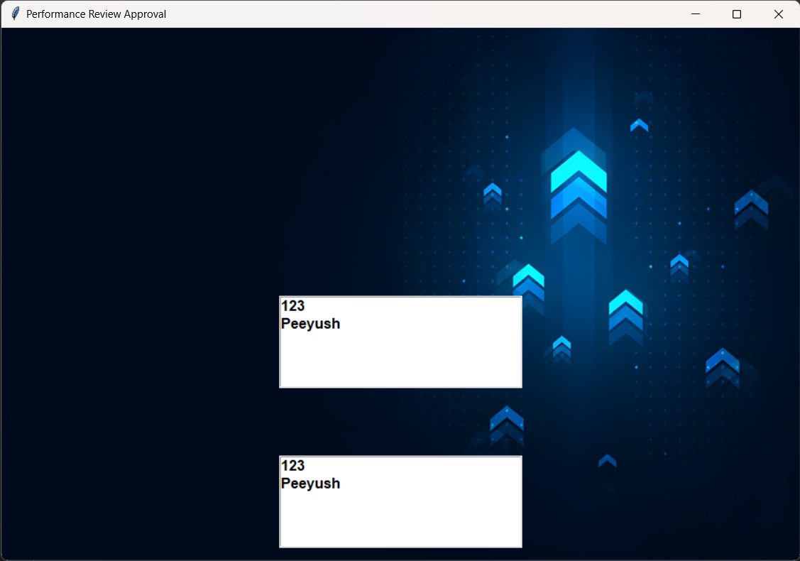

Figure 34

Figure 34: Opens a new window when the approve performance review button is clicked, this displays the list of employees who have filled their quarterly and annual reports separately, clicking each employee’s name will give the information they have filled, that performance review can then be approved or denied by the manager.

34

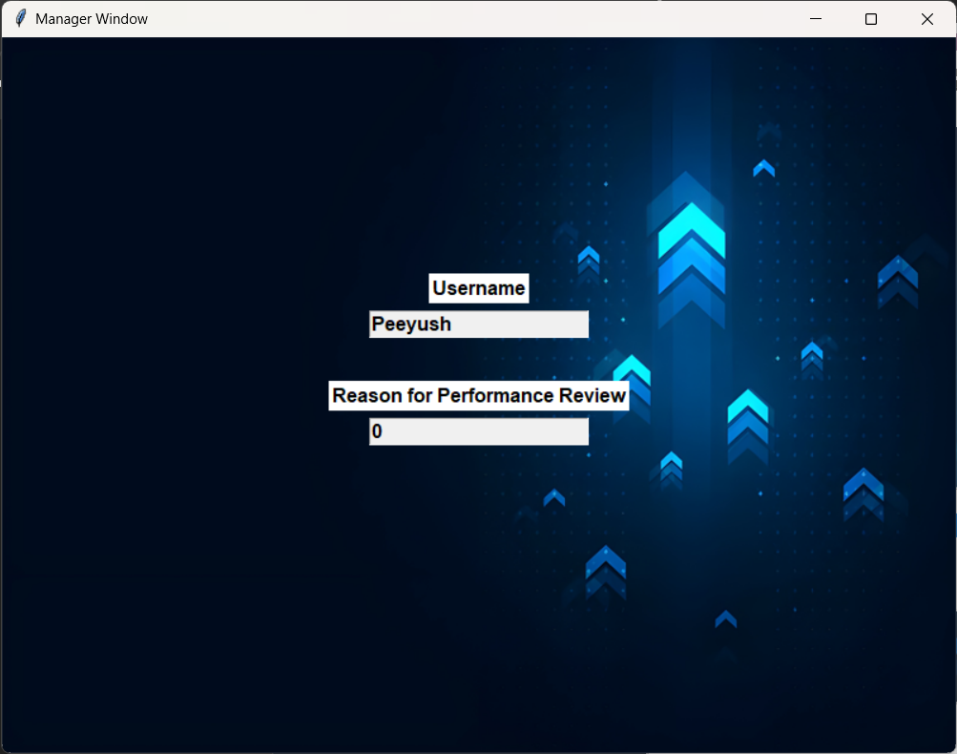

Figure 35

Figure 35: Shows the details of the performance review filled in by the employee along with approve and deny buttons for the performance review.

35

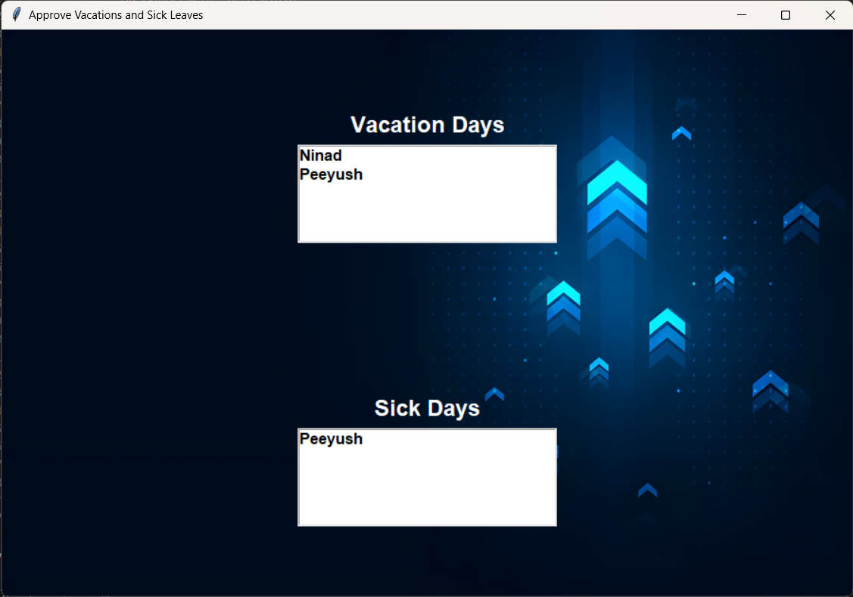

Figure 36

Figure 36: The list of employees whose vacation and sick leave approvals are still pending will be shown in separate list here, the Manager can then click on each user’s name and view the details filled in.

Details for vacations days (figure 37) and sick days (figure 39) are shown separately to reduce confusion for the Manager.

36

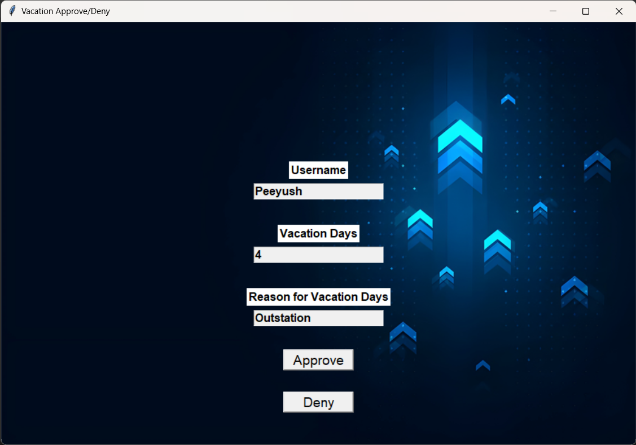

Figure 37

Figure 37: Shows the number of vacation days requested along with buttons to the approve or deny the request by the employee.

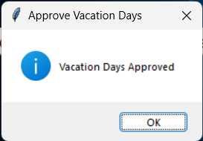

Figure 38

Figure 38: The prompt given to the manager after approval or denial of the request.

37

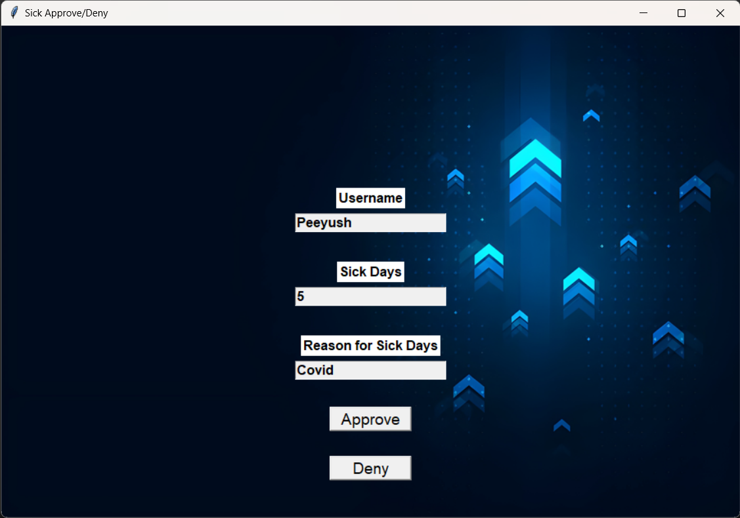

Figure 39

Figure 39: Shows the number of sick days requested along with buttons to the approve or deny the request by the employee.

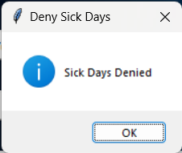

Figure 40

Figure 40: The prompt given to the manager after approval or denial of the request.

38

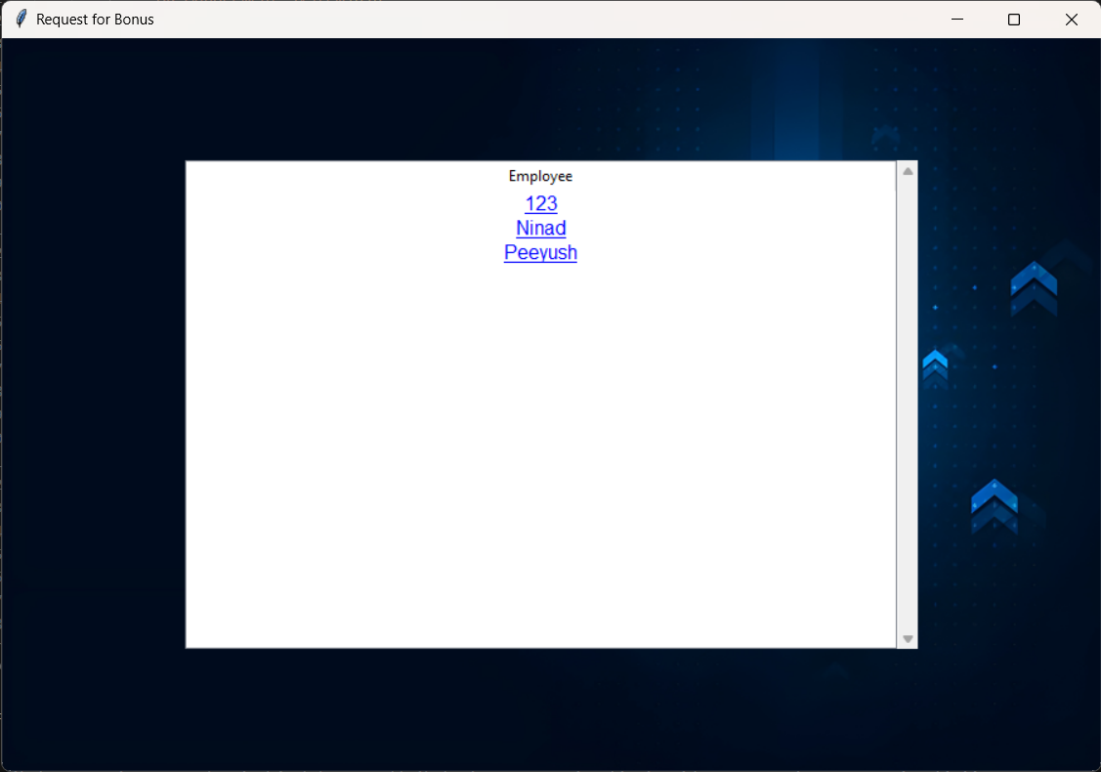

Figure 41

Figure 41:- When the Request for bonus button is clicked a new window is created which gives the list for the employees which are clickable, upon clicking that window a new window is further created (figure 42).

39

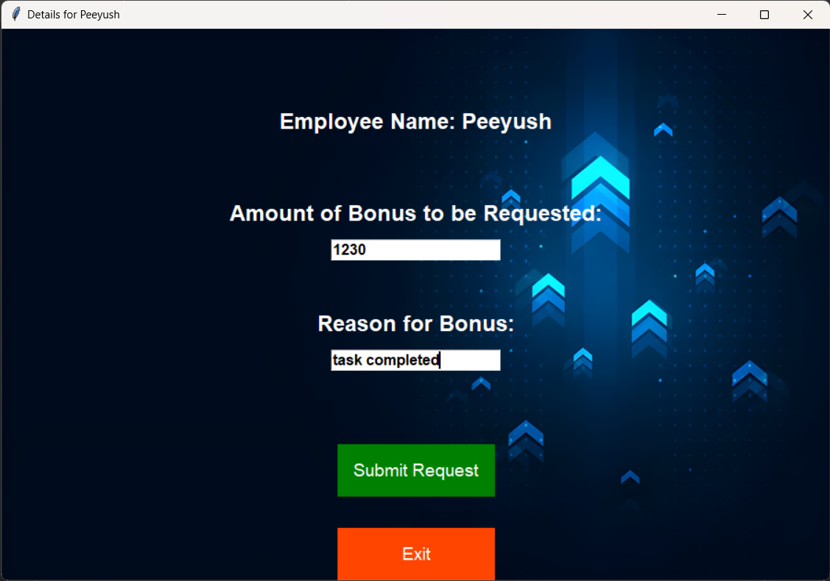

Figure 42

Figure 42: This new window gives the option for the amount of bonus to be requested by the manager for the employee along with the reason for this. There are also two buttons to submit the request or exit from that window.

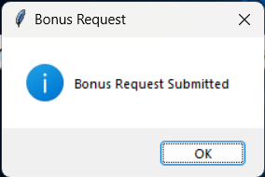

Figure 43

Figure 43: Clicking the submit request button will show this success confirmation and the data will be updated in the DB.

40

Assign for promotion: -

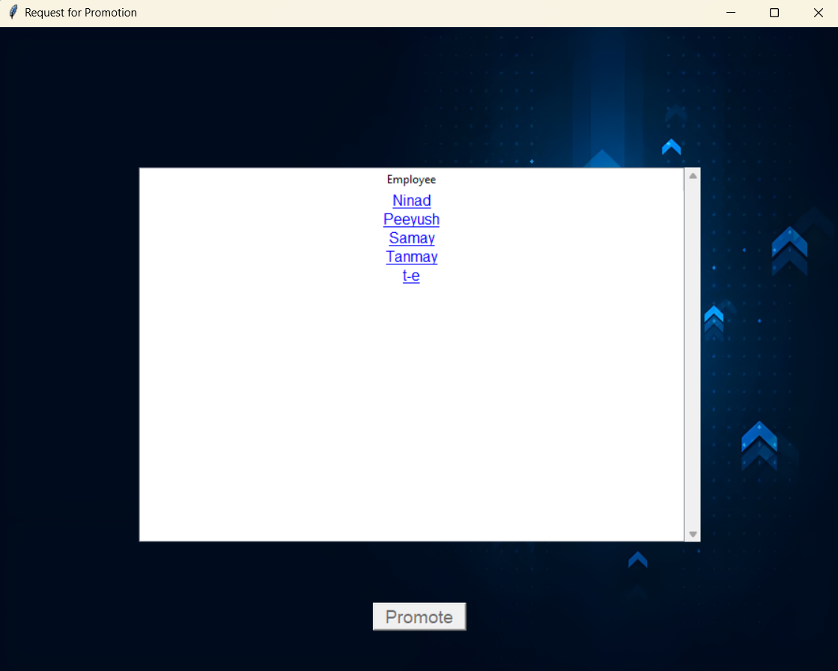

Figure 44

Figure 44: - Upon clicking the Approve promotion button a new window shows up with the list of employees whose promotion approval is pending, upon clicking the respective employee the approve button highlights itself which can then be clicked to approve the promotion.

41

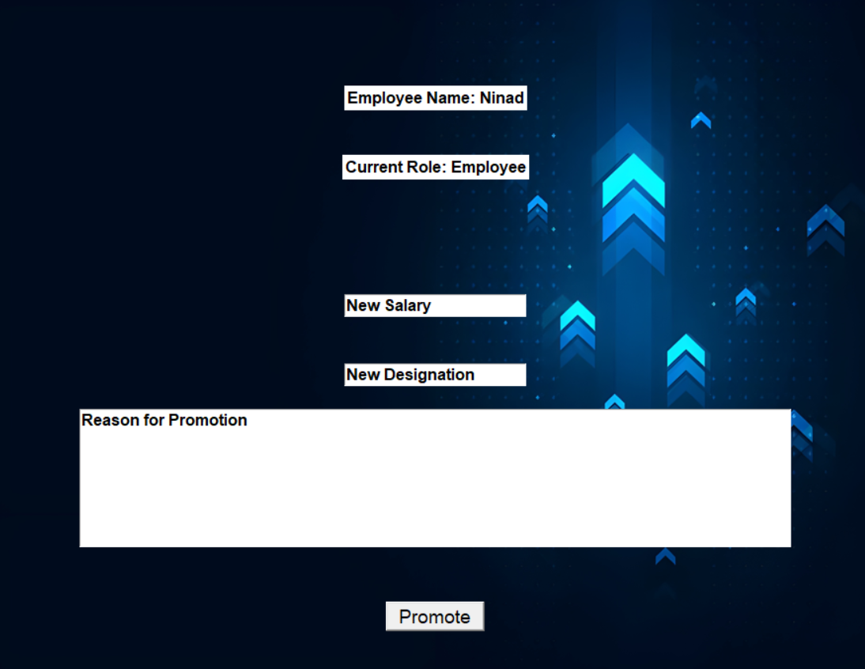

Figure 45

Figure 45: - In this figure with the approve of promotion the salary is updated and the reason for promotion is also stated accordingly with respect to the name and new designation of the Employee

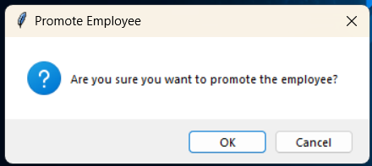

Figure 46

Figure 46: - Clicking the promote request button will show this success confirmation and the data will be updated in the DB.

42

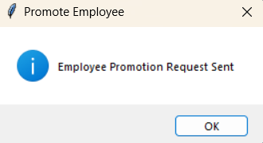

Figure 47

Figure 47:- - Clicking the ok request button will show this success confirmation and the data will be updated in the DB.

Approve resignation: -

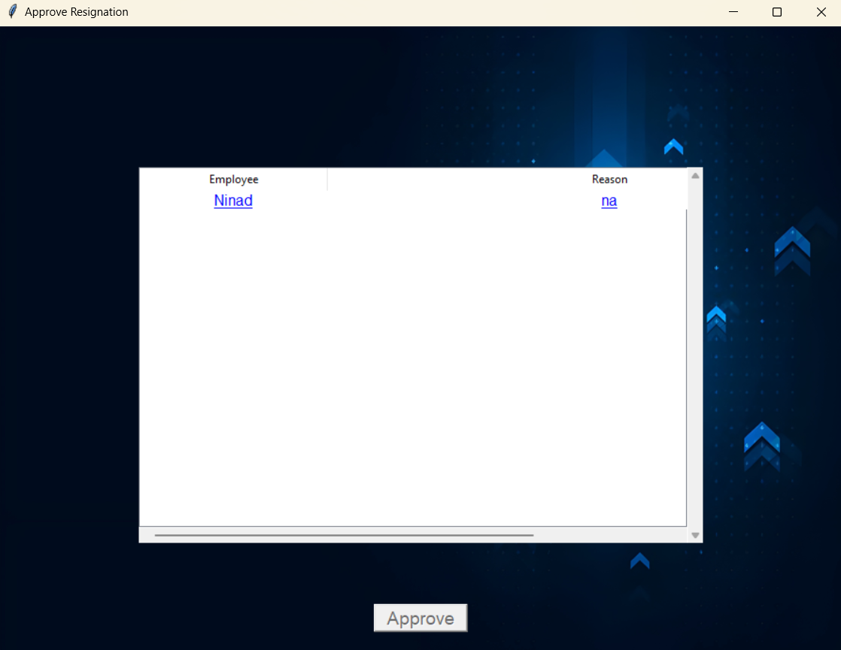

Figure 48

Figure 48: - Upon clicking the Approve resignation button a new window shows up with the list of employees whose resignation approval is pending, upon clicking the respective employee the approve button highlights itself which can then be clicked to approve the resignation.

43

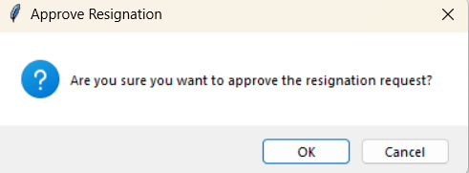

Figure 49

Figure 49: -In this after the approve this window is appear in the screen. The confirmation dialog is shown to the user, upon clicking yes, the details are updated into the DB and the success dialog is shown

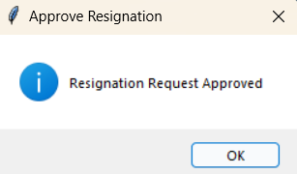

Figure 50

Figure 50: - Clicking the ok request button will show this success confirmation and the data will be updated in the DB.

44

Profile Window for manager: -

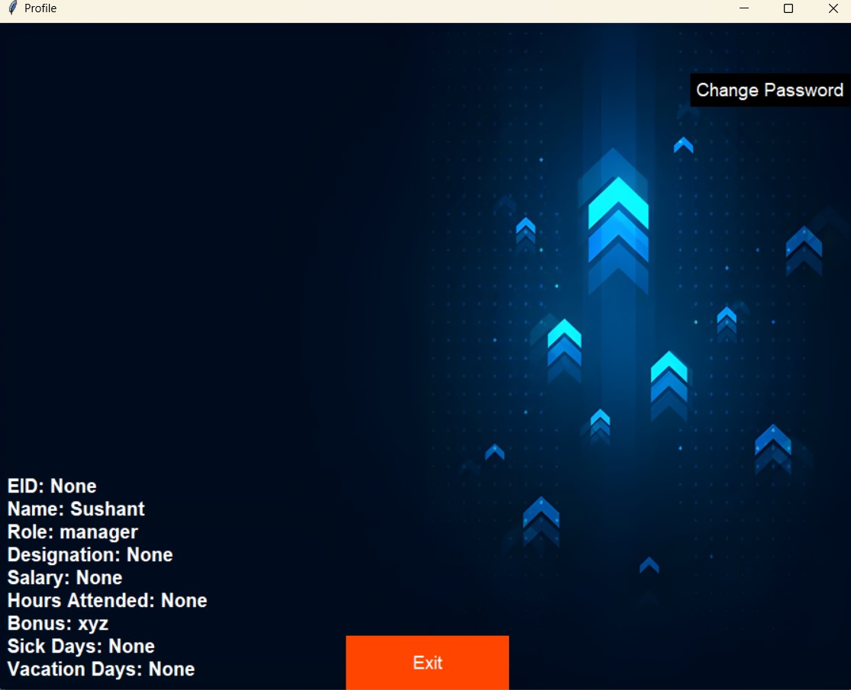

Figure 51

Figure 51: - This Profile screen represents the details for the Manager which shows the Name, EID, Role, Designation, Salary, Hours Attended, Bonus and Sick days leave/ Vacation days leave. The user is also able to change its password through this screen

45

Submit Performance Review: -

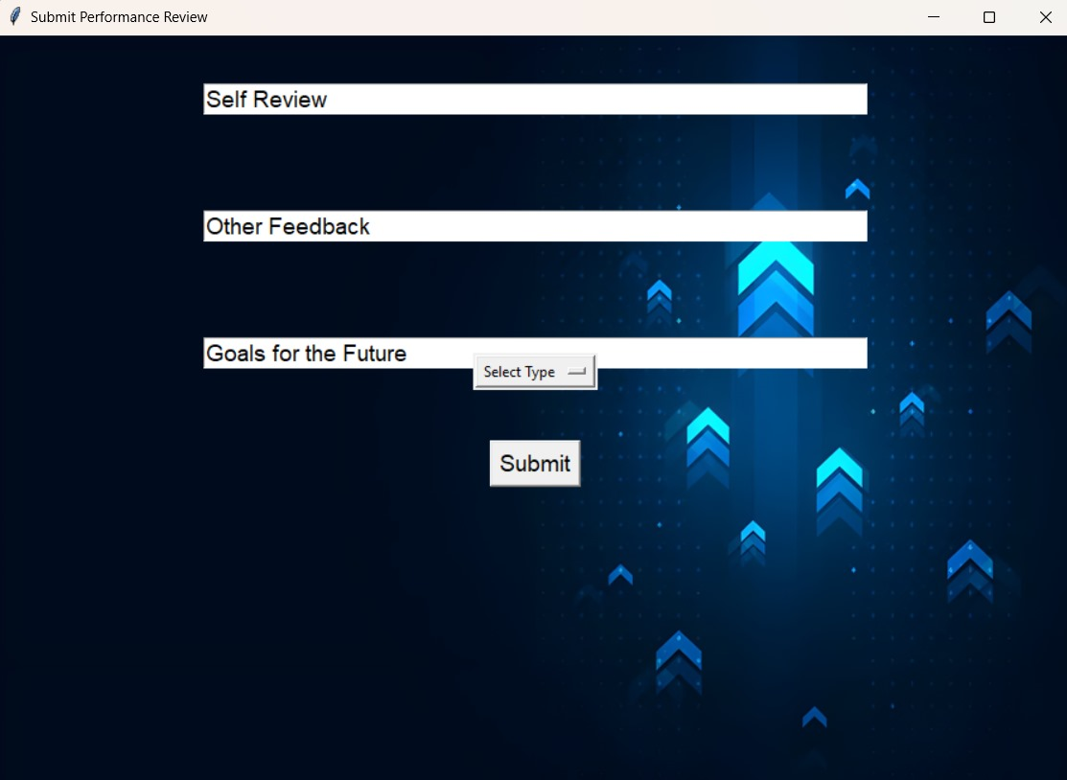

Figure 52

User can provide reviews regarding any kind of concern. This will help the HR to clear the vision and the expectation of the Manager future growth and development goals. Plus, the manager can provide feedback about others regarding there positive or negative concerns respectively

46

Employee Window:

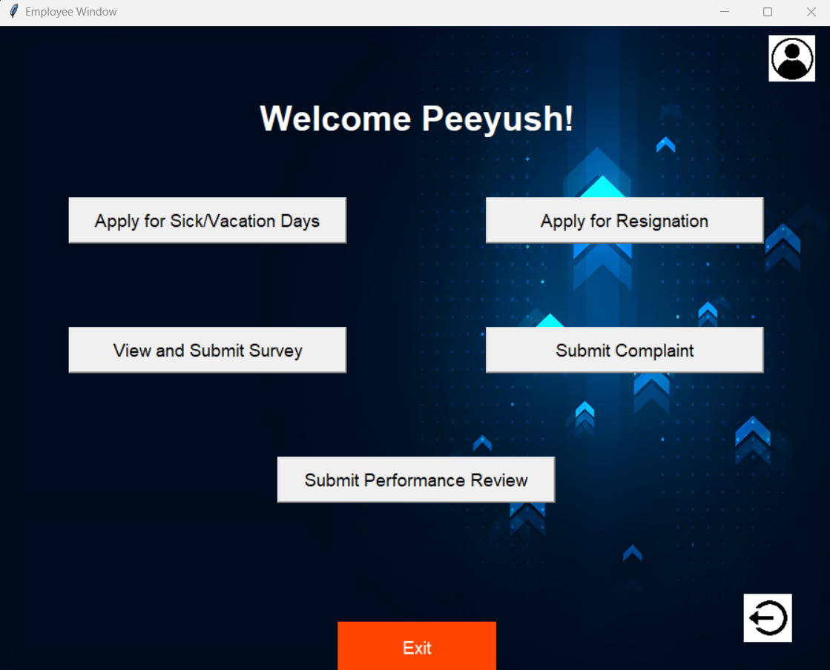

Figure 53

Figure 53: The window shown to the employee role and permission level, it consists of options to Apply for sick/vacation days (figure 54), apply for resignation (figure 57), check and update progress on tasks, view and submit surveys created by the HR(figure 60), submit complaints (figure 62) and submit their own performance review(figure 64).

47

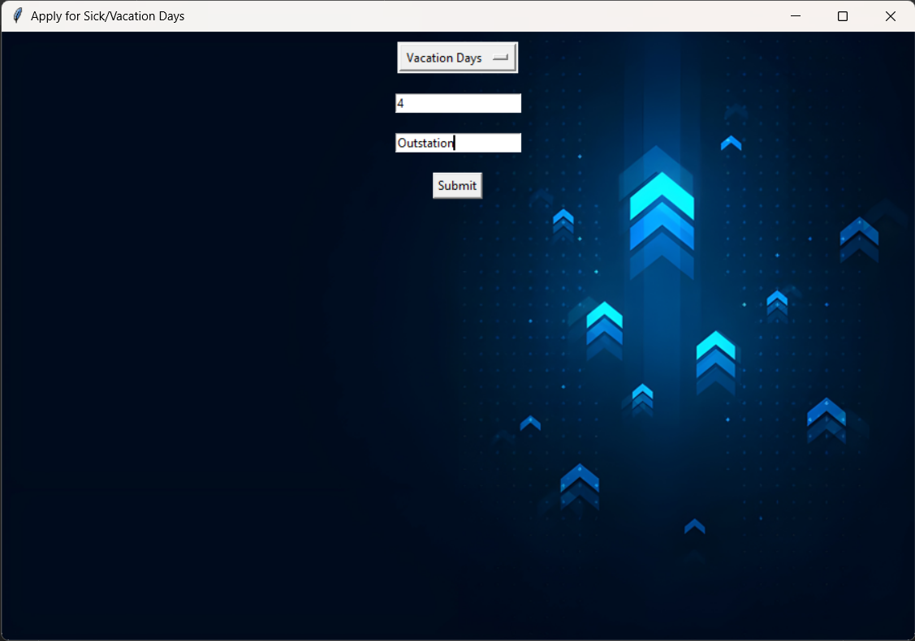

Figure 54

Figure 54: This window is opened when the employee clicks on the Apply for Sick/Vacation days button, it gives the employee the options to choose between the sick (figure 56) and vacation days request along with the number of days to be requested and the reason for the request.

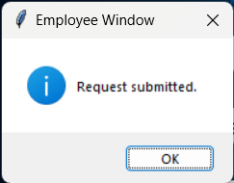

Figure 55

Figure 55: The dialog box shown when the employee submits the request and the data has been pushed to the DB.

48

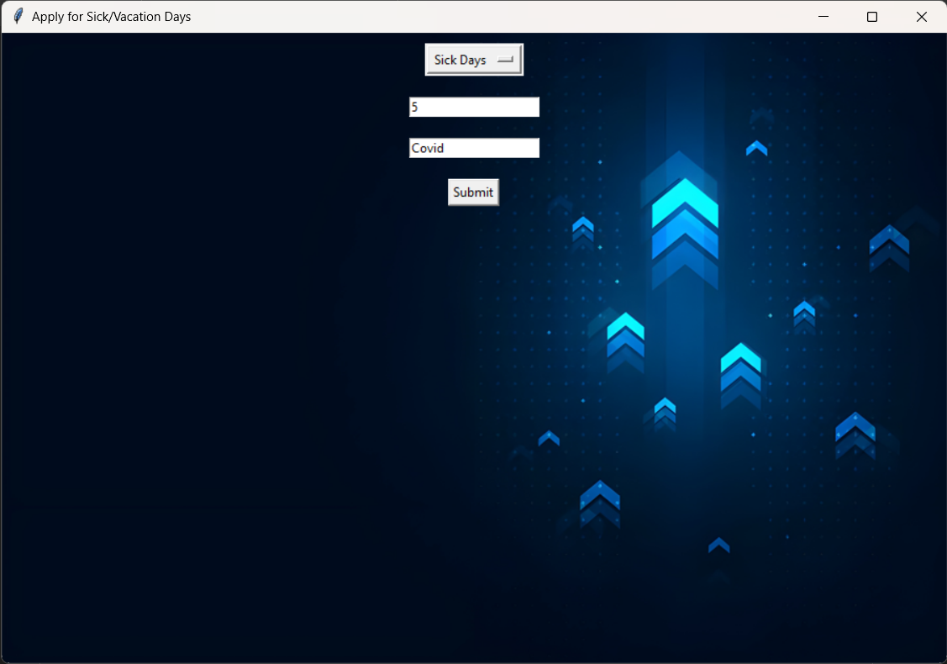

Figure 56

49

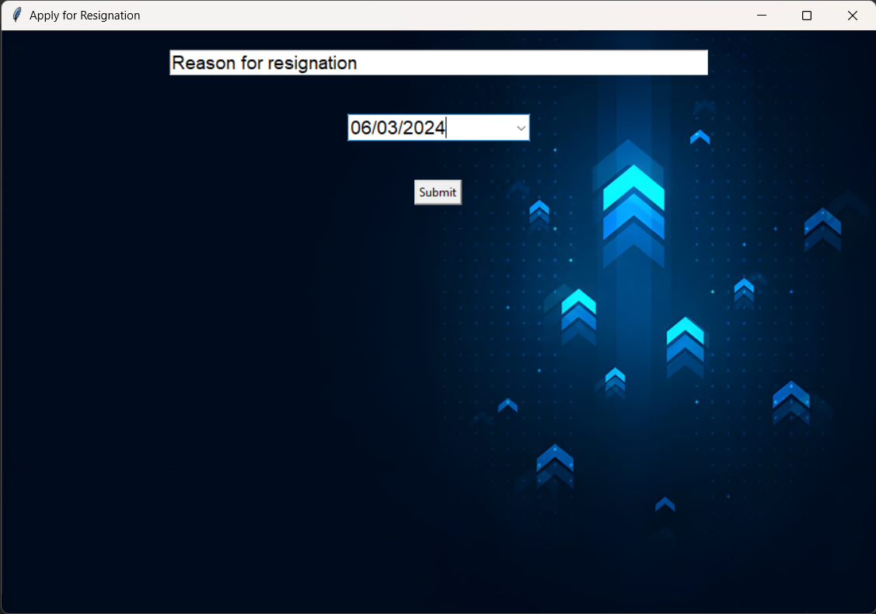

Figure 57

Figure 57: - The window shown when the user clicks on the apple for resignation button, which ask the user for the to apply for resignation (minimum 2 weeks’ notice) along with the reason for the resignation and a submit button to submit the request.

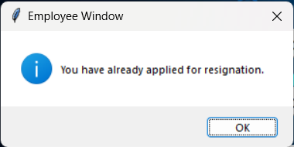

Figure 58

Figure 58: - The dialog box shown when the user has applied for the Resignation by clicking on the submit button.

50

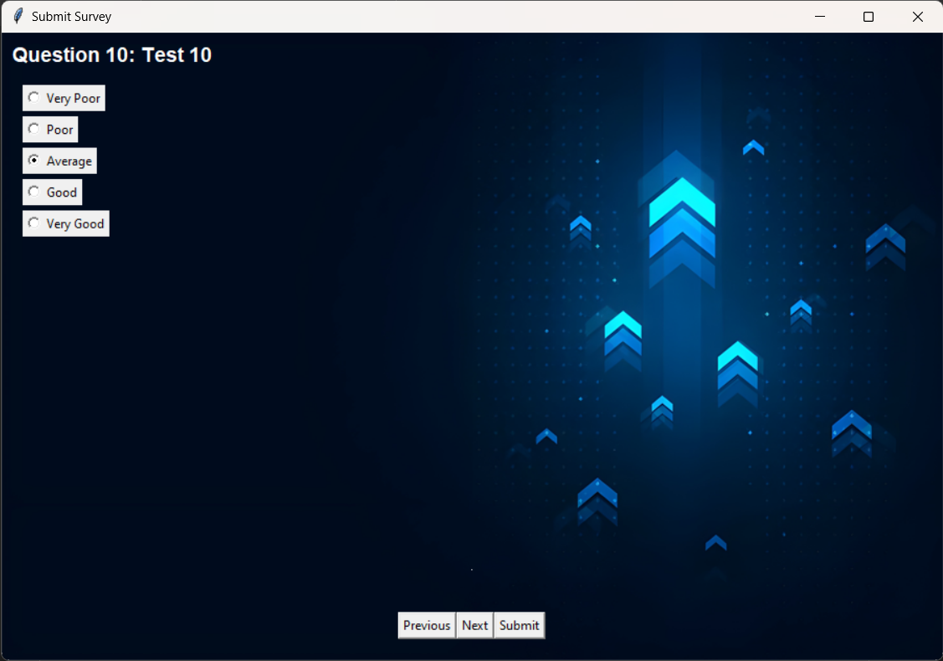

Figure 60

Figure 60: - The window shown when the user clicks on the submit survey button to fill the survey set by the HR for the employees. The questions are displayed along with the question number and the radio buttons for the options, at the bottom of the window there are 3 more buttons for previous, next and submit.

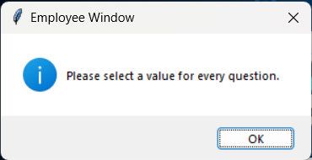

Figure 61

Figure 61: - When the user submits the survey, the Survey submitted window is shown and the data is then stored in the DB.

51

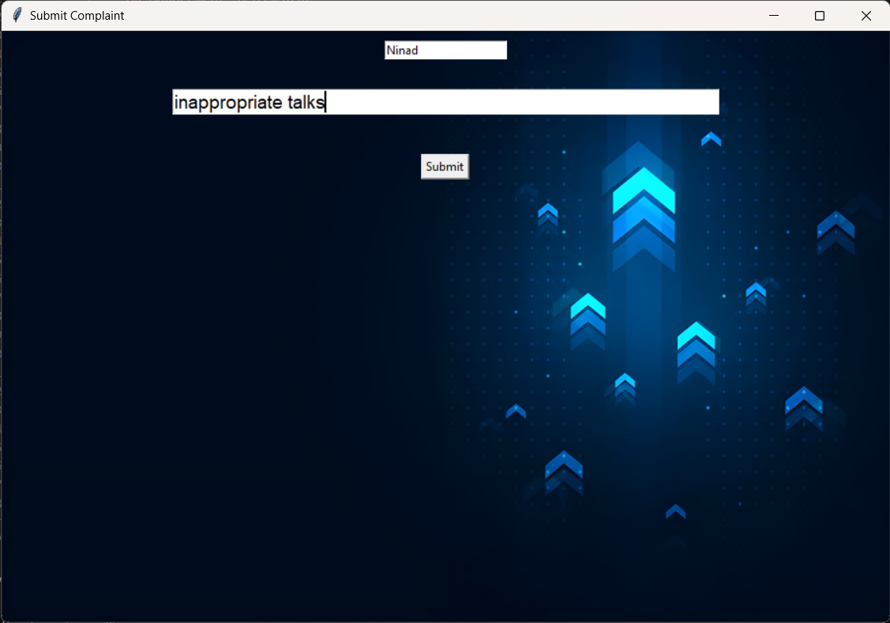

Figure 62

Figure 62: - When an employee clicks on the submit complaint button this window is created which gives 2 input boxes for the name of the employee along with the reason for the complaint, after the two input boxes there is a submit button.

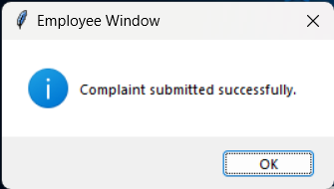

Figure 63

Figure 63: - When the submit button is pressed it shows a success dialog box and sends the data to be stored in the DB.

52

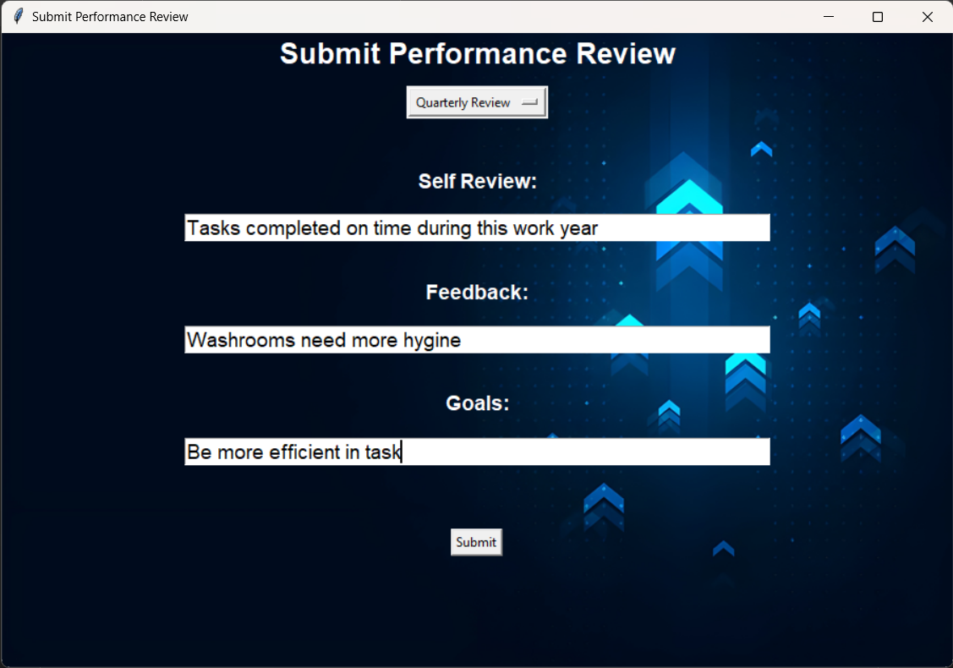

Figure 64

Figure 64: - When the Submit performance review button is clicked this window is shown to the user which gives the option to select from quarterly review and annual review, along with 3 input boxes for their self-review, feedback for the company and future self-goals, below the input boxes is a submit button.

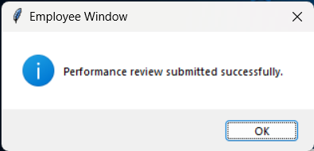

Figure 65

Figure 65: - When the submit button is clicked the success dialog is shown and the data is stored in the DB.

53

Profile For Employee: -

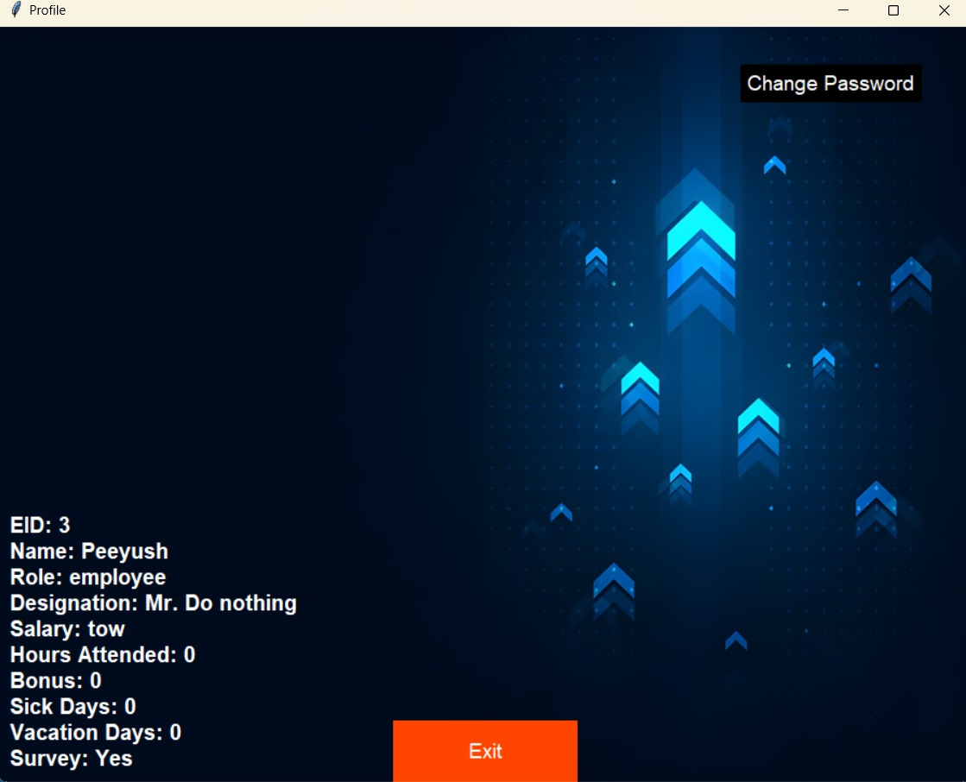

Figure 66

Figure 66: - This Profile screen represents the details for the Employee which shows the Name, EID, Role, Designation, Salary, Hours Attended, Bonus and Sick days leave/ Vacation days leave. The user is also able to change its password through this screen

54

3.5 Conclusion and Future Scope: -

Conclusion: -

The conclusion for an Enhanced E-HR system can highlight its significance in streamlining organizational processes, enhancing employee engagement, and optimizing HR functionalities. It underscores the system's role in promoting efficiency, transparency, and compliance within the organization. Additionally, it may emphasize the importance of ongoing evaluation, feedback mechanisms, and adaptation to evolving HR needs and technological advancements. In conclusion, implementing and maintaining an effective Enhanced E-HR system can significantly contribute to the overall success and sustainability of the organization in today's dynamic and competitive business environment.

Future Scope: -

The future scope of Enhanced E-HR systems is promising and likely to evolve in several key areas:

1. User Authentication and Authorization: Implement more robust user authentication mechanisms such as two-factor authentication (2FA) or OAuth for enhanced security. Also, refine the authorization system to ensure that users only have access to the features and data relevant to their role.
2. User Interface Enhancements: Improve the user interface with modern design principles, responsiveness for different screen sizes, and accessibility features to cater to a wider range of users.
3. Advanced Reporting and Analytics: Integrate data visualization tools to generate comprehensive reports and analytics on employee performance, HR metrics, and managerial insights. This can help in making data-driven decisions and identifying areas for improvement.
4. Integration with External Systems: Enable integration with other enterprise systems such as payroll management, CRM, or project management tools to streamline data exchange and improve workflow efficiency.
5. Mobile Application: Develop a mobile application version of the platform to enable employees and managers to access key features on the go, such as submitting performance reviews, viewing schedules, or checking HR updates.

55

1. REFERENCE

1. Sohail Ahmed, XingKE ,“Human Resource Management: Employees Career Development Impact on Organizational Performance” , Yunnan, China 2016

2. Hewage H.A.S.S, Hettiarachchi K.U, Jayarathna K.M.J.B, Hasintha K.P.C., A. N. Senarathne, J. Wijekoon, “Smart Human Resource Management System to Maximize Productivity” ,Malabe Sri Lanka , 2020

3. Lina Zhang ,“Research on the Application of Human Resources Information Management System under Computer Big iData Technology” , Dalian China , January 2023

4. Yawen Mi, Enduo Gao ,“Design of Human Resource Management System Based on Java EE”, Shanghai China, June 2023

5. D Chavan, A Kiran ,“Dot Diffusion Block Truncation Coding For Satellite Image Retrieval” ,International journal of Computer Applications 124 (4), 24-29

6. D Chavan ,KA Bhandari , “A New Block Truncation Coding (NBTC) For Satellite Image Retrieval Using Dot Diffusion”, IJSER6 (ISSN2229-5518), 9

7. Shayista Majeed , Sabzar Ahmad Peerzadah and Sabiya Mufti, “Electronic Human Resource Management: Need of the Hour", University of Kashmir, July 2020

8. A.S.Syed Navaz, A.S.Syed Fiaz , C.Prabhadevi , V.Sangeetha , S.Gopalakrishnan, “Human Resource Management System”, Sona College of Technology/ Anna University, February 2013

56